**Subject**: **Got a Cyberonics Vagal Nerve Stimulator?**

**Date: May 5, 2016**

Colleagues-

Had a nonverbal patient today with a VNS placed for intractable seizures and did a little bit of digging into properties and behavior of a device.

Mechanics:  Implanted parts are battery, generator, leads, most located in left upper chest, some have battery and generator integrated. An external wand-like magnetic device used for modulation of generator behavior. The idea is that exogenous vagal nerve stimulation may suppress seizure tendency.

Common Manufacturer is Cyberonics (also known as LivaNova) #1-800-332-1375 and ask for Clinical support

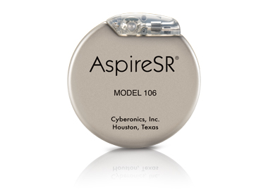

The unique part is the "watch", which patients might bring with them.

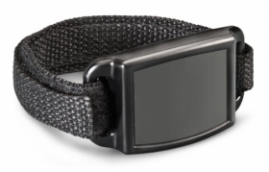

Key differences between VNS and PM/AICDs:

1. Usually, the pacemaker is ON and sends intermittent bursts of signals to the vagal nerve to suppress seizure activity.

2. VNS have no intrinsic sensing and rely on the patient or caregiver to recognize an oncoming refractory epileptic activity

3. Magnetic response is twofold:  **Holding magnet** over it usually turns it COMPLETELY OFF. **Waving "watch"** activates a different mode that is usually stronger electrical bursts.

4. Because it does not sense, electrocautery should not interfere with its intrinsic function, **BUT**, just like any electronic device a direct cautery strike can permanently disable any electrical function.

Sample settings (from my patient today):

**Vagal Nerve Stimulator - Cyberonics brand**

Model number 103 Serial Number 39651

Output current 2.75 mA

Signal frequency 30 Hz

Pulse width 500 usec

Signal on time 21 seconds (

Signal off time 1.8 minutes

Magnet current 3 mA

Magnet pulse width 500 usec

Magnet on time 60 seconds

i.e. device will put send 30hz stimulation for 21s, then stop for 1.8 minutes, then repeat. If a magnet is waved, it will send 3 mA current for 60s

**X. E. Dong, M.D.**

**Temple Anesthesiology**