Thrombelastograph® (TEG®) Coagulation Analyzer

TEG is a „real time“ analyzer of whole blood for coagulation. TEG measures the viscoelastic properties of the hemostasis process functionally, the end-result being the hemostatic plug, or clot.

Objectives of TEG-Guided Therapy

* To distinguish between anatomical and coagulopathic bleeding
* To distinguish primary from secondary fibrinolysis, including the consumptive phase
* To reduce the use of unnecessary blood products and reduce thrombotic complications
* In a bleeding patient – helps differentiate anatomical and coagulopathic bleeding
* May help identify patients at risk for delayed bleeding or thrombosis

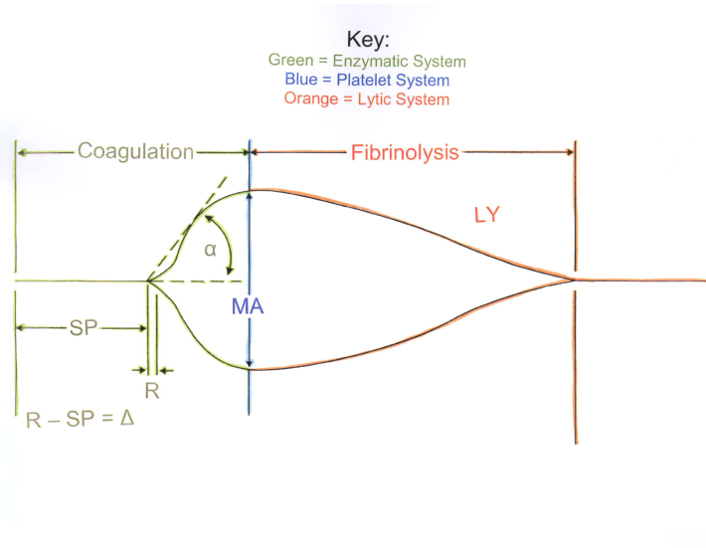

**SP = Split Point, time to first fibrin strands**

**R = Reaction time to end of thrombin burst**

**K = fibrin cross-linkage, fibrinogen function**

**Angle = fibrinogen function**

**MA = platelet function in mm**

**G = MA converted to Kdynes/cm2**

**EPL/LY30 = Estimated Percent Lysis, clot breakdown**

**Analysis of TEG**

**To make transfusion decisions with TEG results, go by the numbers. See the tracing below. The bottom of the TEG has numerical values for SP, R, K, Angle, MA, G, and EPL and LY30. Break the numbers up in Pairs (ie. SP and R, K and Angle, MA and G, EPL and LY30)**

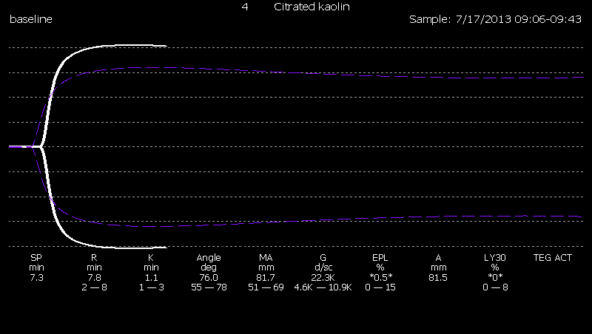

* **SP & R**
  + **Are the coagulation factor(s) function normal, hypocoagulable, or hypercoagulable?**
* **K and Angle**
  + **Is the fibrin(ogen) function normal, hypo, or hyper?**
* **MA and G**
  + **Is platelet function normal, hypo, or hyper?**
* **EPL/LY30**
  + **Is the fibrinolytic system normal, or hyper?**

**Remember the mnemonic: FFP.**

* **If SP & R are prolonged think FACTORS or Heparin (FFP or Protamine)**
* **If K and Angle are prolonged think Fibrinogen (Cryoprecipitate)**
* **If MA and G are decreased think Platelets (Platelets)**

**See below.**

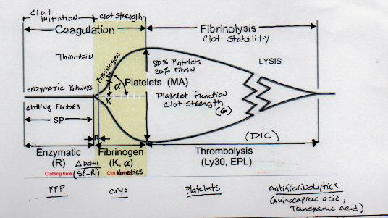

Look to the Algorithm (in Power point) to develop a treatment strategy.