**TEG Citrix access**

Login to bswportal.sw.org

🡫

Click on “**+**” sign on the middle left of the screen to add apps

🡫

Select All Apps

🡫

Click on the TEG icon to add to your favorites

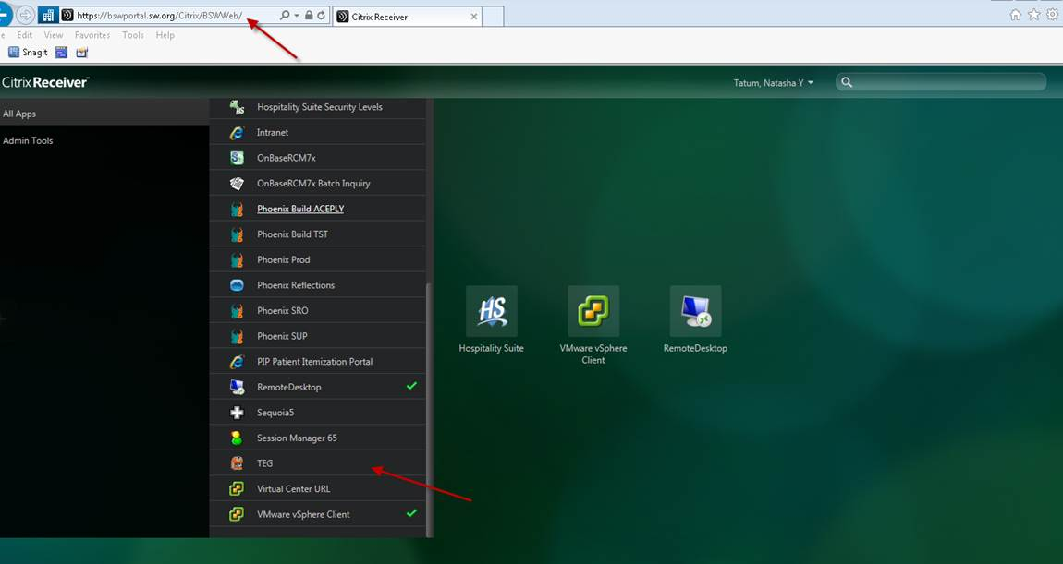

Select the TEG icon (double click)

🡫

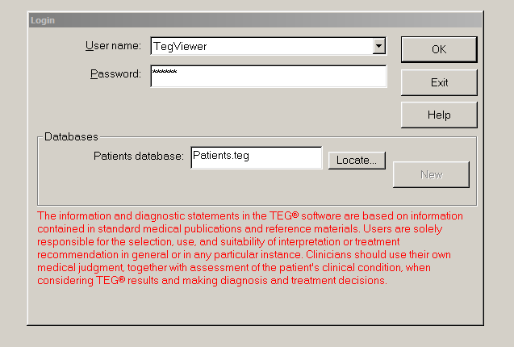

Select the Username: **TegViewer**

Password: **viewer** (all lower case)