DRAFT as of 8/26/15

**Labor and Delivery Grease Board Tip Sheet**

The Epidural Rounding tab of the L&D Grease Board has been revised (as of Sept 1).

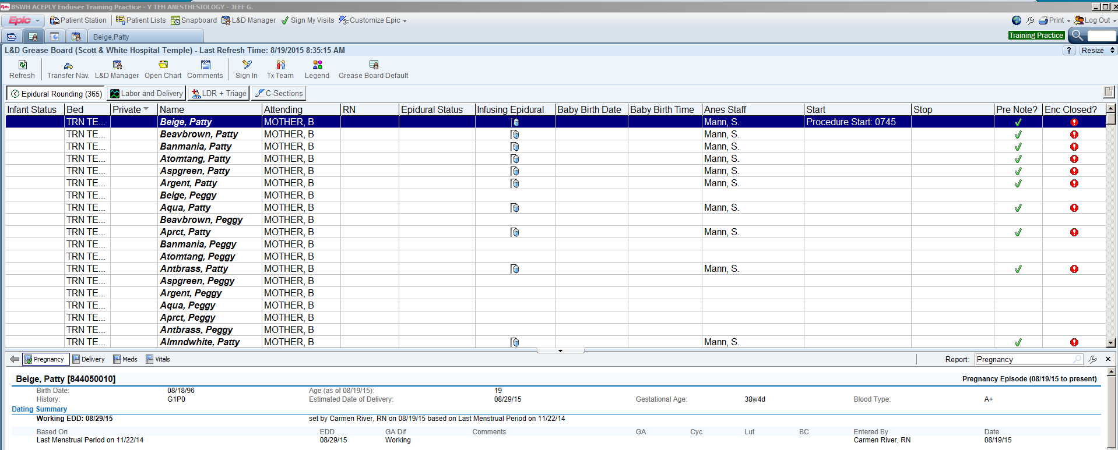

The display of patients can be sorted by the contents of any column by clicking in the column header.

E.g. - sorting by the “Bed” column will separate the active labor rooms from the post partum rooms.

Sorting by the “Enc Closed?” column will bring all unclosed encounters to the top (or bottom) of the list.

One click will display patient info in the bottom panel. A double click will open an anesthesia record.

Most columns are from the current OB versions of the grease board.

The new columns that contain Anesthesia related information are:

Infusing Epidural – the hanging bottle icon means the patient has an active Epidural LDA.

Baby Birth date and time will populate from the OB delivery record.

Anes Staff – displays the currently assigned Anesthesia Care Team – Senior Staff and Resident.

Start – shows the Procedure Start time of labor analgesia record

Stop – shows the Procedure Stop time of the labor analgesia record

Pre Note? – the green check mark icon indicate a Pre Evaluation Note has been completed

Enc Closed? – the red hex icon indicates the encounter has not yet been “Closed.

For example, in the next screen shot, the top case is completed. The epidural LDA is “removed.” (Birth date and time will be filled in.) The full anesthesia team (Sr. Staff and Resident) is documented. Procedure Start and Stop have been entered. The Pre Eval note was done. And, the encounter has been Closed and is ready for billing

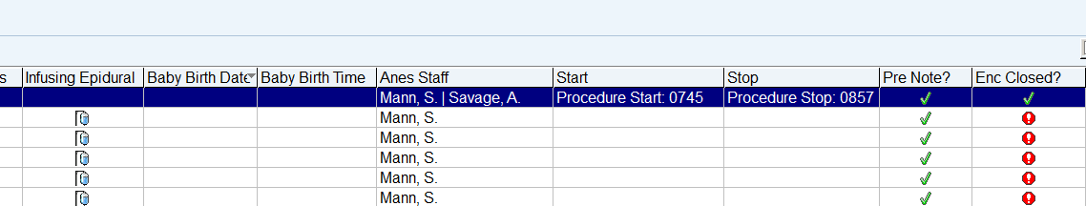

Prepared by J. R. Gibson, MD – Aug 19, 2015

DRAFT Standard work tasks for Labor Epidural Analgesia

The Epidural Rounding tab of the L&D Grease Board has been designed to facilitate the hand off of L&D responsibilities at Resident shift changes and at Senior Staff changes. By doing the following items of “standard work” at each staffing change there should be no unfinished labor records.

Recommended “standard work” tasks:

At each change of staffing, the departing and arriving personnel review the Epidural Rounding grease board together, either in person or by phone, and check the following items:

1. Sort the display by the “Infusing Epidural” column to review all active epidurals.

* Each active epidural should have the Anes Care Team updated to the new team and any management issues should be discussed.
* Any “active” epidural that shows a Baby Birth date/ time should have the record reviewed, finalized and closed.

1. Sort by “Pre Note” - any patients who have been evaluated but have no epidural placed should be reviewed.
2. Sort by “Enc Closed?” - be sure that records on all patients who have delivered have been closed.
3. Is it worthwhile to check the C-Sections tab during the “shift change”?