**Tip Sheet for Labor Epidural Record Staffing Time Lines**

J. R. Gibson, MD July 8, 2015

The Labor Epidural Analgesia (LEA) Ad Hoc case illustrated below does not have the staffing time lines (the purple bars) set properly.

When the staffing button is opened you can see the default time bar runs from Anes Start to Anes Stop; since these events are not used for an LEA, the case will not process properly for billing.

The purple time lines should begin and end with the Procedure Start and Procedure Stop times. This is most easily done at the end of the case after these two event s have been entered into the record.

(But, depending on your local procedures, the time bar can be started once the Procedure Start event has been entered and the ended after the Procedure Stop event has been entered, using the same steps shown below.)

I have illustrated this process below. Please contact me if you have any questions of suggestions.

Thanks,

J. R. Gibson, MD Beeper 0873, Email jgibson@sw.org

This screen shot shows the incorrect time line displayed by clicking the “Staff” button:

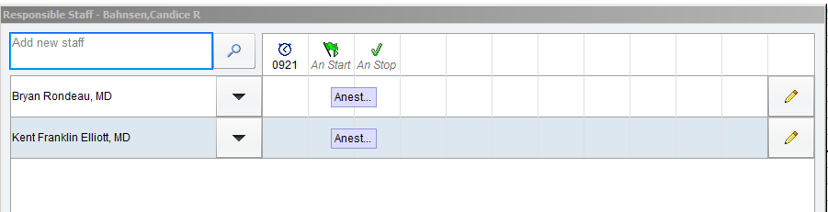

To correct these time lines; click once in one of the purple time lines.

In the Modify Staff Entry window (see below), click on the Green Flag (the choose event time button) next to the “Begin” Time entry window. From the drop down list of events choose the “Procedure Start” event.

Then click on the Green Flag (choose event button) next to the “End” Time entry window. From the drop down list of events choose the “Procedure Stop” event. (This is the step illustrated in the screen shot below.)

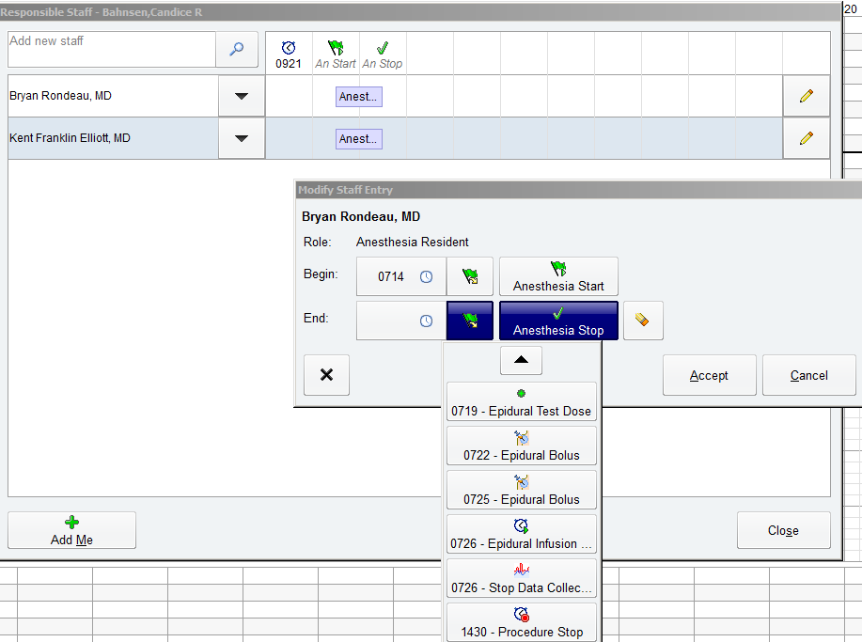

After one time bar is set correctly, click in the newly created time boxes to correct the second time bar.

