# Documentation and Communication – DIFFICULT AIRWAY

B. B. Vacula, M.D. & J. R. Gibson, M.D. October 2015

For patients exceptionally hard to intubate or a difficult airway, the DIFFICULT AIRWAY LETTERS should be routinely completed. (See form letters named: “Difficult Airway Letters” dated Oct. 6, 2015)

Postoperatively, talk with the patient and their loved one(s) and give them a completed copy.

Scan original into Epic.

In addition, be sure to add “Difficult Intubation” to the patient’s Anesthesia History in Epic per screenshots below to flag for future providers in Central.

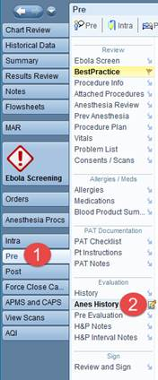 

Additional steps in documenting a Difficult Airway or Difficult Intubation.

4. Click on the Note box to open the details window.

5. Enter the date (of the Anesthetic record documenting the difficulty)

6. Enter a brief free-text comment describing the problem.

7. Click the “Add to Problem List” button to make a permanent entry in the patient’s Problem List.

Then click “Accept” to close the Details window.

*See Illustration below*

