How to order and interpret a TEG, organized by F. Villamaria, MD MPH

**Ordering a TEG**

**Draw a Blue Top Citrated Tube to the etched marking on the tube**

This tube **MUST** be labeled with

1. Patient’s First and Last Name
2. Date, time(from the computer) and the collector’s initials

**Complete TEG Requisition form**

Forms are located

1. In every OR
2. Available upon request from the Blood Bank
3. On Insite <http://insite.sw.org/web/iwcontent/private/LabResources/pdf/Forms/TEG_Requisition_Form.pdf>

A requisition form **MUST** accompany **EVERY** sample; ***including redraws***

**Required documentation**

1. **Label with patient’s information**
2. **Room number** – required for relaying specimen acceptability
3. **Collection Date, Time (from a computer), collectors initials, ordering physician, form completed by**
4. **Anticoagulants** (if any)
5. **Indications** Trauma Cardio Other
6. **Type of specimen**
   1. Pre bypass baseline TEG/ Pre-Op Blue top
   2. Outpatient baseline TEG Blue top
   3. Syringe whole blood—ON PUMP Syringe
   4. Syringe whole blood - 10-minute post Protamine Syringe
   5. ICU: Citrated whole blood Blue top
   6. For Trauma or other Indications
      1. Other: Citrated whole blood Blue top
      2. Other: Syringe whole blood Syringe

**Specimen Run time**

1. Blue top – **MUST** be run 10 mins to 2 hours after collection
2. Syringe – **MUST** be run 4 minutes after collection

**Order TEG in EPIC and Collect Specimen**

**HAND-DELIVER SPECIMENS TO THE BLOOD BANK**

**DO NOT SEND SAMPLES THROUGH THE PNEUMATIC TUBE SYSTEM**

**Some Definitions**

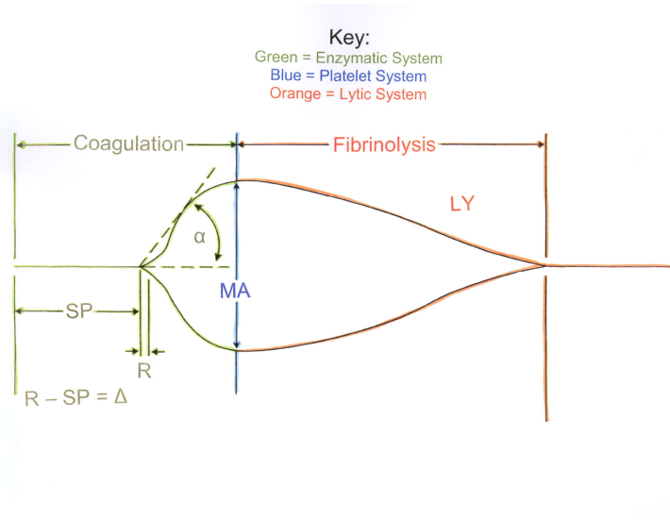

**SP = Split Point, time from start to waveform split; time to first fibrin strand development**

**R = Reaction time to end of thrombin burst; time from SP to when waveform reaches 2mm above baseline**

**K = fibrin cross-linkage, fibrinogen function; time from 2mm above baseline to 20mm above baseline**

**Angle = fibrinogen function, (slope between R & K)**

**MA = platelet function in mm**

**G = MA converted to Kdynes/cm2**

**EPL/LY30 = Estimated Percent Lysis, clot breakdown**

**Normal TEG tracing and normal ranges**

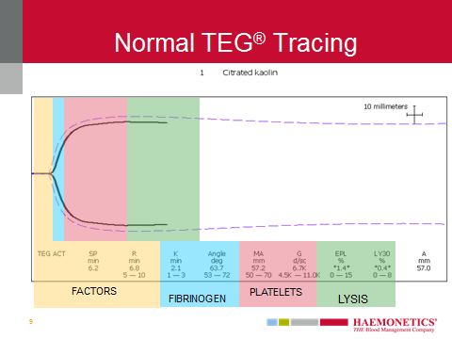

**Citrated Kaolin normal ranges** **Kaolin normal ranges** **RapidTEG normal ranges** **Citrated RapidTEG**

R = 5-10 minutes 4-9 minutes N/A N/A

TEGACT = N/A N/A 78-110 seconds 86-118 seconds

Delta (R-SP) = 0.7-1.1 minute 0.7-1.1 minute N/A N/A

K = 1-3 minutes 1-3 minutes 0.5-2.0 minutes 0.6-2.0 minutes

Angle = 53-72 degrees 59-74 degrees 66-82 degrees 64-80 degrees

MA = 50-70 mm 55-74 mm 54-72 mm 52-71 mm

G = 4.5-11.0 Kdynes/cm2 5.3-13.2 Kd/cm2 5.3-12.4 Kd/cm2 5.2-12.2 Kd/cm2

LY30 = 0-7.5% 0-7.5% 0-7.5% 0-7.5%

**Interpreting a TEG**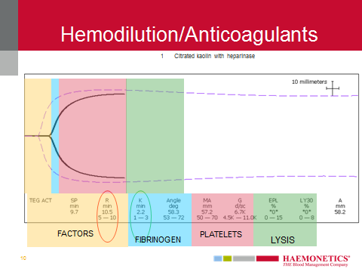1. **How fast does the clot begin to form**? Look at R value and Delta (R – SP). Examine thrombin activity first, not just because it is the first result we see on the tracing, but because hemostasis is a thrombin-driven process. If you don’t have enough thrombin, nothing else is likely to perform normally, either.

* If R and delta are normal, factor function is within normal limits
* If R or delta are shortened, thrombin burst is hypercoagulable (may consider anticoagulation to reduce thrombotic risk, depending upon circumstances)
* If R is prolonged, but delta is < 1.1 minutes, this reflects **hemodilution**. No treatment is necessary for hemostasis.
* If both R and delta are prolonged, this represents factor deficiency or anticoagulant effect.

2. **Does the R shorten by 2 minutes or more in the heparinase sample**? If yes, then heparin is a contributor, consider additional protamine.

3. **If R does not significantly shorten with heparinase, then either it is a non-heparin anticoagulant, or it is factor deficiency**. Consider FFP, if the patient is bleeding.

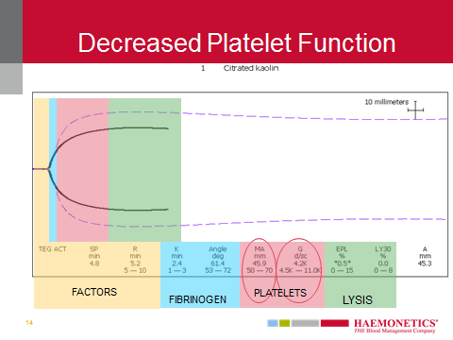

1. **How strong is the clot**? Look at MA and G

* If MA and G are low, platelet function is decreased. Consider platelets, if patient is bleeding.
* If MA/G are normal or high, and patient is bleeding, there may be platelet inhibition that was not anticipated. Consider DDAVP. DDAVP cleaves vWF/fVIII and has a major improvement in platelet adhesion to the endothelium. It has a mild effect on increasing platelet aggregation, and the fVIIIa will help amplify the coagulation cascade, potentially shortening both the R and K values slightly.
* If the patient has an elevated MA/G at baseline, consider whether antifibrinolytics should be used during the case. These drugs are contraindicated in hypercoagulable states. If the MA value is above 65mm, or the G is above 9.2 Kd/cm2, studies show an increasing risk of thrombosis. (This patient is likely to be able to withstand CPB without major problems of hemostasis.)

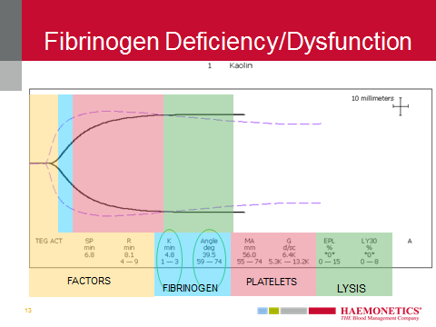

* If thrombin and platelet function is normal, **how quickly is the clot growing**?

Look at K (and/or angle) for fibrinogen function. K is about 80% fibrin and 20% platelets. Angle is about 50/50%.

The reason to check thrombin and platelets activity first, is that both FFP and Platelets contain some fibrinogen. About 400mg of fibrinogen is in a bag of platelets, and about 300mg in a bag of FFP. Correcting those two problems first, may also resolve any fibrinogen deficits.

* If K is prolonged after correction of thrombin and platelets, and bleeding is occurring, consider Cryoprecipitate.

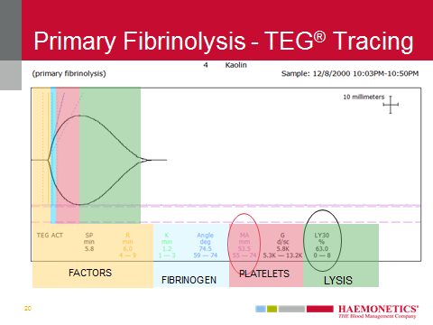

1. **How stable is the clot?** Look at LY30 for fibrinolysis.

* If LY30 is > 7.5% and MA is low, this represents primary fibrinolysis. Consider antifibrinolytics. (In severe trauma, consider antifibrinolytic if LY30 is > 3%.)
* If LY30 > 7.5% and MA is high, with short R, this represents stage 1 DIC. Treat the underlying cause. (May consider anticoagulation to interrupt the hypercoagulability, and help prevent them becoming consumptive.)

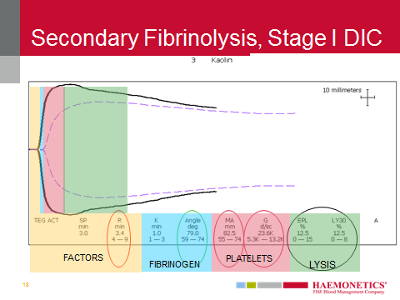

**Summary: What a TEG shows, and an easy interpetation mnemonic**

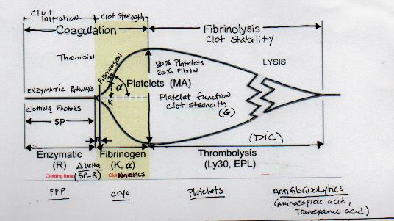

**Remember the mnemonic: *FFP*.**

**If SP & R are prolonged think *Factors* or Heparin**

**If K and Angle are prolonged think *Fibrinogen***

**If MA and G are decreased think *Platelets***

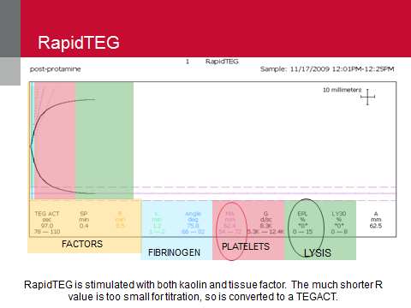

**Rapid TEG**

Will be used primarily for Trauma cases. A rapid TEG uses both kaolin and tissue factor thereby further speeding up the reaction. In the Rapid TEG assay, the R-value is replaced by the TEG-ACT value which is measured in seconds rather than in minutes. The remainder of the TEG parameters do not differ between a standard and rapid TEG

**Getting TEG results in real time**

In OR’s 22-27 TEGs can be viewed and displayed on the OR screens.

TEGs can also be viewed by accessing Citrix. In order to use the Citrix viewing option, you must be given access. This may already have been done for you. If you find that you do not have access, contact Yasmine King, Chief Technologist, Blood Bank by phone (724-2932) or by email.

**TEG Citrix access**

Login to bswportal.sw.org

🡫

Click on “**+**” sign on the middle left of the screen to add apps

🡫

Select All Apps

🡫

Click on the TEG icon to add to your favorites

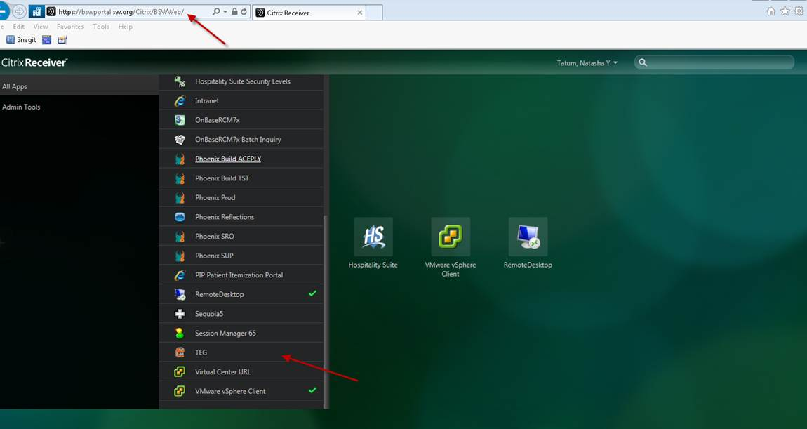

Select the TEG icon (double click)

🡫

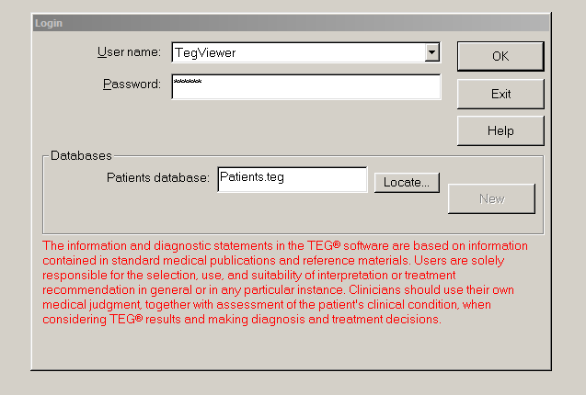

Select the Username: **TegViewer**

Password: **viewer** (all lower case)

**References**/**Acknowledgements**:

Training material from Haemonetics Corporation

Explanatory material from Mr. Dan Mason, Technical Representative for Haemonetics

Ordering a TEG section developed by Ms. Yasmine King