We are making changes so that you can edit sign and hold orders. This change is in place already. Please let your staff know. All anesthesia users will have this tool.

Daniel

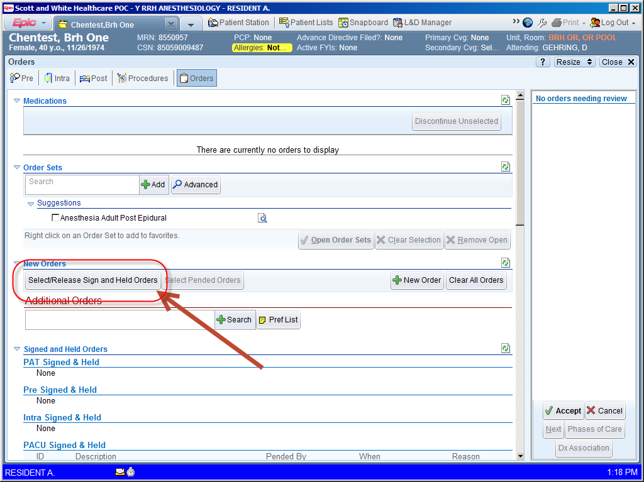

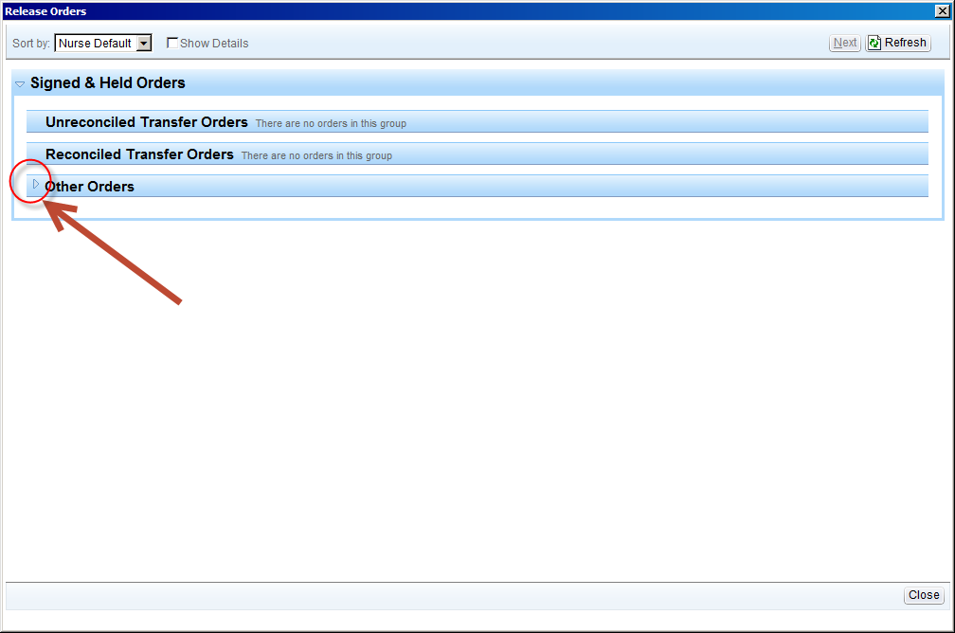

1. Select drop down arrow and select modify or discontinue

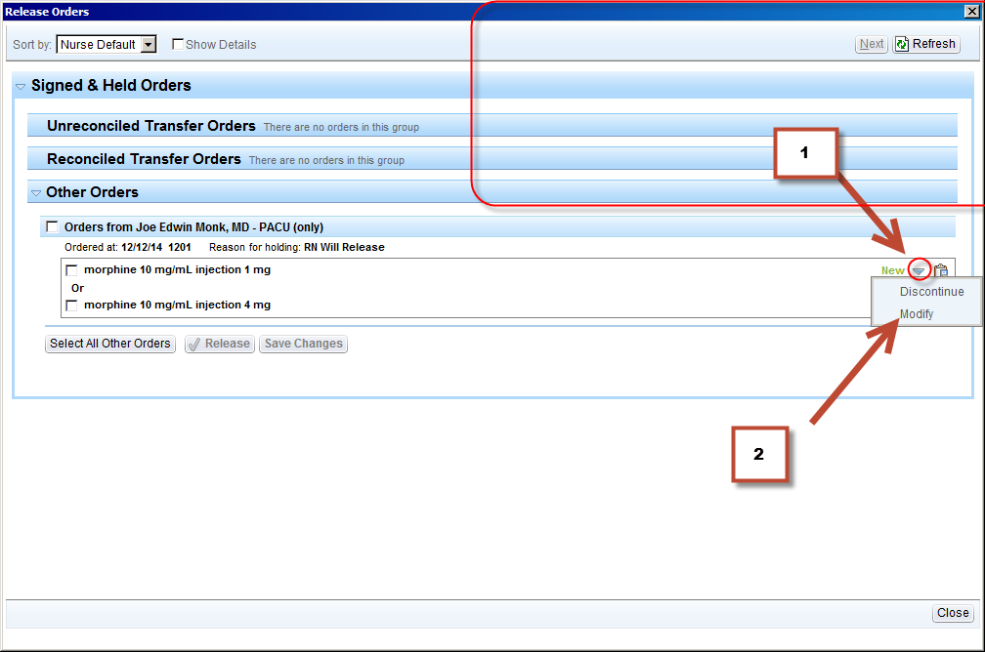

3. Accept any changes you make

4. Close to save changes (keep it sign and held) or release orders

