**AAU Guidelines**

Most people know the job of the AAU physician at this point, but it was felt having a guiding document would be helpful. The first portion is about the daily job itself. There is a portion regarding the handling of consults after it.

The hours are roughly 6am – 2pm. This can vary, depending on if it’s Thursday or not.

Most patients arrive around 6 – 6:30. You’ll be dancing around the pre-op nurses as they try to accomplish their job as well. Please be considerate of them, as they’ve a lot of patients to get ready too. Generally they work in teams of two and on one side of DOSC. I find if I start on the other side from them, we all rotate around the unit and don’t step on each other’s toes.

You’ll want your status board (note: status board, not snapboard) to be TEH Day Surgery. This will show you a listing of all the DOSC bays, including all pertinent information. Almost all the way to the left will be a red circle with an exclamation point icon. Every patient with one of those needs a pre-op. Once you click the pre-op as ready, it goes away.

During the day, you’ll likely need to order meds for pain for some patients, or anxiety, or deal with glucose issues. Occasionally you’ll see a patient with medical or airway issues requiring you to contact whomever will be performing their anesthetic.

**Pre-Admission Testing Consults**

While consults are rare for AAU, they come up often enough that we need a process for it so we aren’t reinventing the wheel each time. Below is the process that generates a note that is attached to the consult request and which will show up in the CONSULTS tab of the patient’s record. Billing is included below as well. Consults should come with a reason as to why we’re seeing the patient, as it isn’t always readily apparent.

*To Do a Consult*:

1. Find the patient through Patient Station
2. Look in Encounters. You’re looking for a consult for TEH Pre-Admission Testing
   1. Make sure you change the dates searched for. Mine defaulted to two months prior for some reason.
3. Double click on it. It’ll come up with a list of possible visits to chart under. Ours is never there, so….
4. CREATE NEW PROCEDURE: One is PAT. That’s the one you want.
5. In order to generate a consult note that will fill the requirements, you need to go to the NOTES tab along the left hand side.
6. Up top, click NEW NOTE
7. For the type, it’s CONSULTS
8. Choose the service (ANESTHESIOLOGY AND PAIN MANAGEMENT)
9. It gives a blank page. Type in your consult. (See the next page for note requirements.)
10. Sign the note

*Charges*:

1. After doing the note, look for CHARGES
2. New charge
3. Click in this order, each of which is a subgroup that opens up:
   1. Professional Charges
      1. Consult
         1. Outpatient
            1. Choose a new patient visit, of whatever length you spent
            2. Click on it to choose a diagnosis

I picked the diagnosis that matched the reason the patient was sent to us (i.e., COPD).

1. File charges

*The Note*:

In order to successfully bill for the consultation, our note needs to contain the following:

History of Present Illness

Review of Systems

Limited Physical Exam

Assessment / Plan

Three of these you’ll be free texting. But for the Review Of Systems part, you type in .ROS

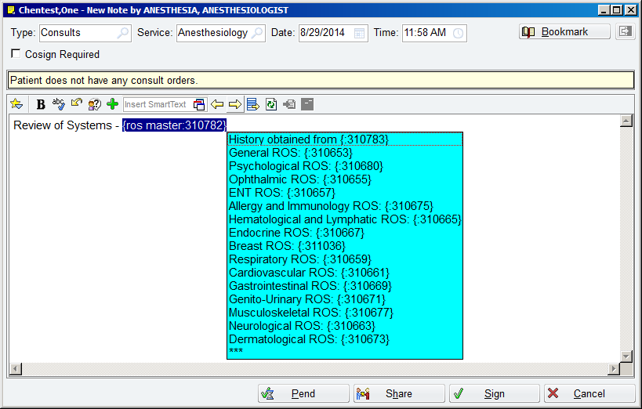

Pick the Review of Systems you want to use and it’ll bring up a script text like we use for our post-op evaluations. Follow it up with an exam and assessment/plan, sign the note, and you’re golden.